**How to use TRA (Windows C/C++ version)**

This TRA version is based on Window 10 and Microsoft Visual Studio 2017 (or higher). It requires the installation of HDF library (version 4.2.11) for reading the HLS product (HDF format).

When you open ***TRA.sln***, you need to check configuration. Choose ***Release*** and ***x64*** (Figure 1), and then make sure:

(1) ***Use MFC in a Shared DLL*** (Figure 2);

(2) ***Use Multi-Bytes Character Set*** (Figure 2);

(3) Add the ***include and library directories*** of HDF (Figure 3);

(4) Add ***_CTR_SECURE_NO_WARMINGs*** into preprocessor (Figure 4).

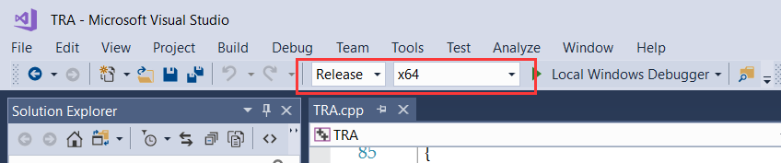

Figure 1

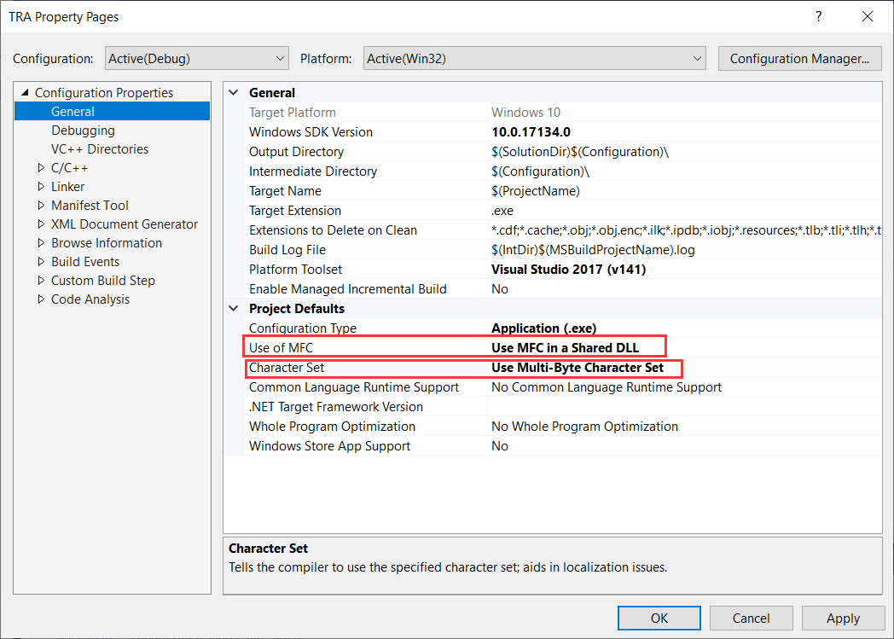

Figure 2

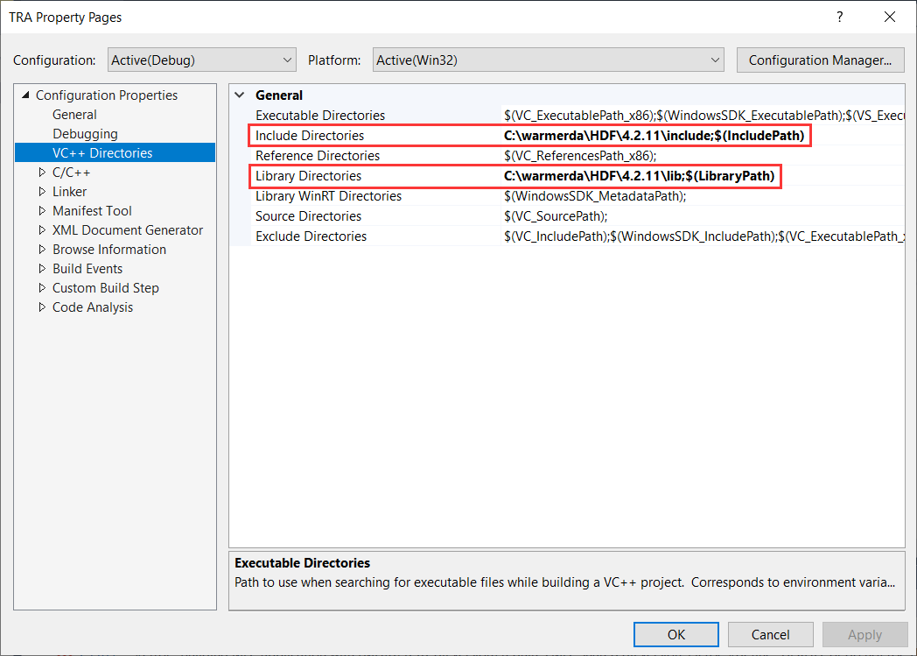

Figure 3

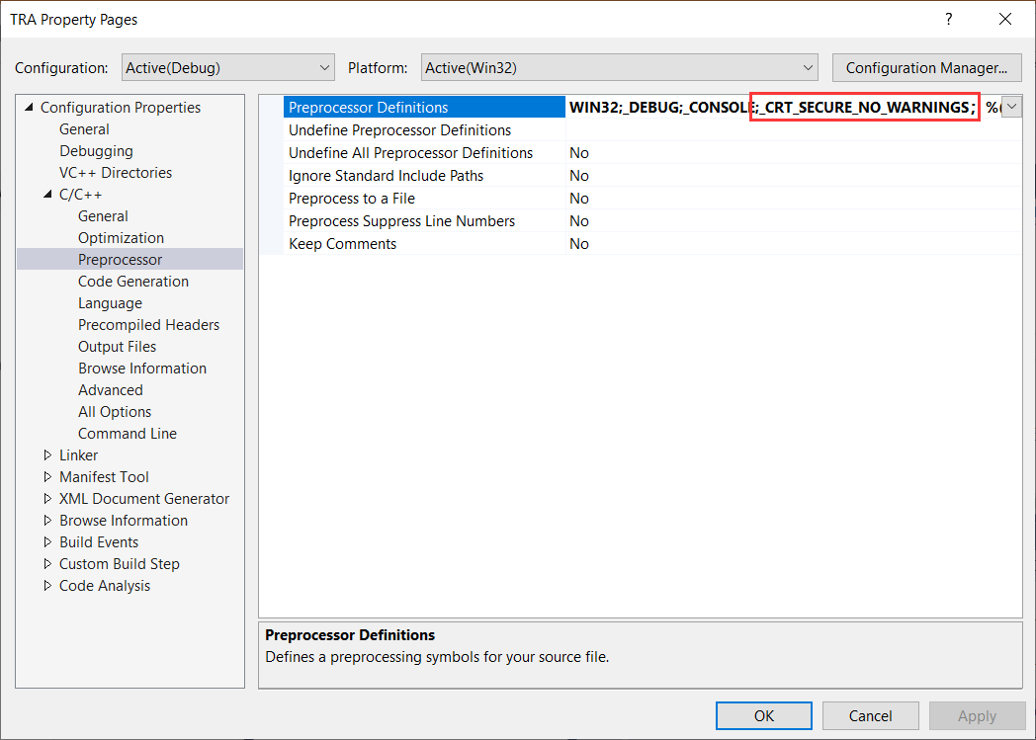

Figure 4

There are two functions for running TRA: one is for a single pixel and the other is for the MGRS tile.

When running a single pixel, you need to define the path of L30 and S30 point data (CSV format) and the output path of fitted parameters (TXT format). As shown in Figure5, the CSV file should be organized as nine columns (***Year, DOY, Blue, Green, Red, NIR, SWIR1, SWIR2,*** and ***ClearFlag***). The ***ClearFlag*** labeled as 1 means the clear-sky observation.

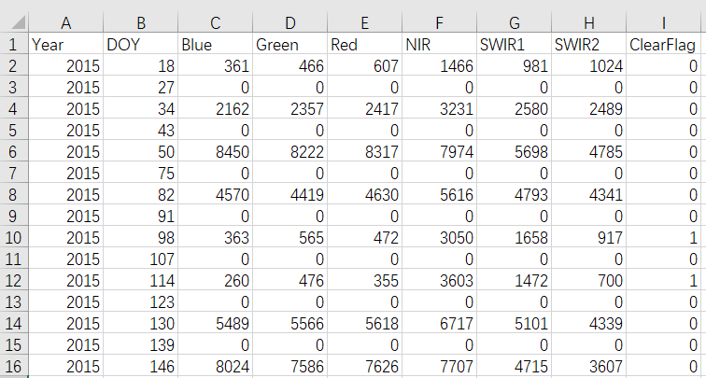

Figure 5

When running a MGRS tile, you need to create the TXT file (Figure 6) for all paths of the HLS L30 or S30 files (use the command: ***dir *S30*.hdf /s/b >pathS30.txt***), and then define the paths of two TXT files and the output path of the HDF file with the fitted parameters.

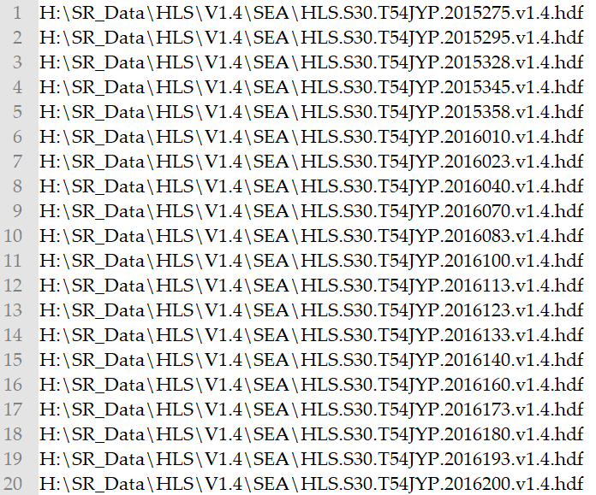

Figure 6